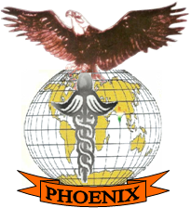

PHOENIX PARAMEDICAL COLLEGE

WELCOMES ALL OF YOU ON

FRESHER’S WELCOMES WEEK

( COLLEGE-STUDENTS RELATION BUILDING WEEK)
"Moving on to a new stage in life can be a challenging process. We wish you the best of luck in all of your endeavors , you will be great! "

