The blood
Blood is a connective tissue and provides one of the means of communication between the cells of different parts of the body and the external environment. It is an extracellular fluid of the body, which circulates in a closed system of blood vessels. Normally, its physical and chemical composition always remains constant, within the physiological limits and helps in maintaining the homeostatic balance in the body. Blood makes up about 7% of body weight.

Functions of the blood
The blood carries out number of important functions in the body, they are as;
- Transport of respiratory gases: It carries the oxygen from the lungs to the tissues, where it is utilized and carbon dioxide from the tissues to the lungs, from where it is expelled out.
- Nutrition: It carries the food materials absorbed from the intestines to the different tissues and cells. It also carries nutritive materials from one part of the body to the other.
- Drainage of waste products: It carries the waste products of cellular activity and brings them to the organs of excretion, i.e. kidneys, lungs, intestines, etc..
- Transport function: It acts as a transporting vehicle through which the hormones, vitamins and other essential chemicals are brought to their place of activity.
- Protective function: Blood cells namely neutrophils, monocyts, lymphocytes and plasma proteins play an important role in the defence mechanism of our body.
- Maintenance of water and fluid balance.
- Maintenance of acid-base equilibrium by means of its affective buffering power and with the help of kidney, skin and lungs.
- Maintenance of ionic balance between the cells and the surrounding fluid.
- Regulation of body temperature
- By the property of coagulation it guards against hemorrhage.
- Helps in the regulation of blood pressure.
Composition of blood
Blood is composed of a straw-colored transparent fluid, plasma, in which different types of cells are suspended. Plasma constitutes about 55% and cells about 45% of blood volume.
Plasma
The constituents of plasma are water (90-92%) and dissolved substances , including:
- Plasma proteins( albumins , globulins, clotting factors )
- Inorganic salts
- Nutrients, principally from digested foods.
- Waste materials.
- Hormones.
- Gases.
Cellular content of blood
There are three types of blood cells;
- Erythrocytes ( Red blood cells)
- Thrombocytes (Platelets)
- Leukocytes (white blood cells).
All blood cells originate from pluripotent stem cells and go through several developmental stages before entering the blood. Different types of blood cells follow separate lines of development. The process of blood cell formation is called as haemopoiesis, and takes place within red bone marrow. In adults haemopoiesis in the skeleton is confined to flat bones, irregular bones and the ends (epiphysis) of long bones , the main sites being the sternum, ribs, pelvis and skull.
The erythrocytes (Red blood cells)
Red blood cells are non-nucleated biconcave discs and their diameter is about 7 micrometers. Their main function is in gas transport, mainly of oxygen, but they also carry some carbon dioxide. The cells are flexible so they can squeeze through narrow capillaries, and contain no intercellular organelles, leaving more room for hemoglobin, the large pigmented protein responsible for gas transport.
Stages of development of RBCs
The process of development of RBCs from pluripotent stem cells takes about 7 days and is called as erythropoiesis. The stages in the development of RBCs are as follows;
- Proerythroblast: It is the first stage. It is a large cell having a nucleus. Initially it has no hemoglobin and later hemoglobin starts appearing.
- Normoblast (Erythroblast): It is the second stage cell. The cell is smaller with degenerated nucleus but hemoglobin is fully present.
- Reticulocyte: It develops from Normoblast and contains hemoglobin and reticulum in the cytoplasm.
- Erythrocyte: it is a fully developed RBC. It does not contain reticulum, but contains adequate hemoglobin.
Both folic acid and Vitamin B₁₂ are necessary for the formation of RBCs.
Control of erythropoiesis: The number of red cells remains fairly constant, which means that the bone marrow produces erythrocytes at the rate at which they are destroyed. This is due to a homeostatic negative feedback mechanism. The life span of erythrocytes is about 120 days and their breakdown or hemolysis is carried out by phagocytic reticuloendothelial cells.

Physiological variations in the number of red cells:

- High altitudes: in the high altitudes over 10,000 feet above sea level, the red blood cell count will increase. The immediate increase is due to lowered O2 tension in the high altitudes and occurs by mobilization of blood cells from reservoir of blood(spleen in response to anoxia)
- Muscular exercises and certain emotional states: this causes temporary increase in the number of RBCs.
- High environmental temperature also causes liberation of blood from splenic reservoir.
- Reduction in the number of RBCs occurs at high barometric pressure( e.g. mines), in haemorrhage, in excess hemolysis and in bone marrow failure.

The haemoglobin

Hemoglobin is the coloring matter of erythrocytes. The respiratory function of the blood is carried out by the hemoglobin.
Chemical constitution and structure:
Hemoglobin is a conjugated protein consisting of an iron containing pigment portion called Haem or Heme (4%) and a protein of the histone class called as globin (96%). Haem is an iron containing porphyrin known as iron protoporphyrin IX (metallo-porphyrin).Therefore, haemoglobin is an iron+ porphyrin+ globin compound.
Four haem molecules are attached to the globin molecule to form one molecule of haemoglobin. The porphyrin nucleus consists of four pyrrol rings joined by four methyl (C-) ‘bridges’. The porphyrins are the tetrapyrrols. H
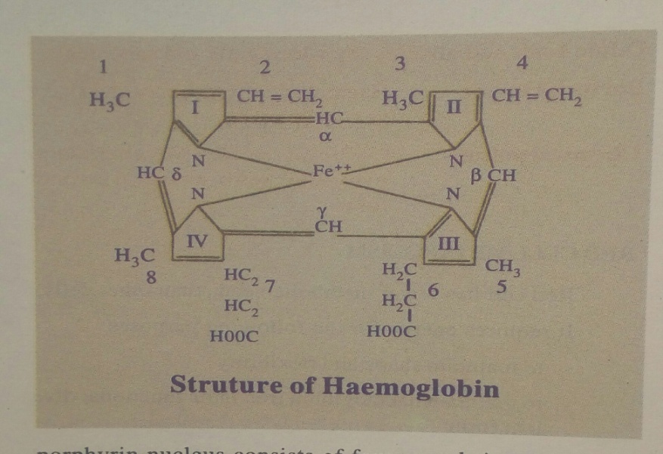
Structure of haemoglobin
Hemoglobin formation in the body
Hemoglobin is formed in the blood-forming organs of the body. Raw materials necessary for synthesis of hemoglobin must be available in adequate amounts. Iron, porphyrin, the protein globin are necessary for hemoglobin formation. Synthesis of hemoglobin includes the synthesis of different polypeptide globin chains and of heme. It occurs in the nucleated red cells of the marrow during 6-8 days of erythroid cell maturation. Low level synthesis occurs for a day or two in reticulocytes. No synthesis occurs in the matured erythrocytes.
Functions of hemoglobin:
- Transports oxygen and carbon dioxide.
- Maintains acid-base equilibrium.
- Source of bilirubin formation- Bilirubin is formed from porphyrin fraction of hemoglobin of the disintegrated RBC.
Tests to evaluate Body Iron Status:
- Bone marrow’s smear or biopsy for evidence of storage iron as granules of haemosiderin.
- Plasma level of transferrin which increases as iron stores are depleted.
- Total iron binding capacity (TIBC) is measured.
- Radio immunoassay of plasma ferritin-serum ferritin level.
Less than 12µg/l is diagnosed as iron deficiency.
The leukocytes (White Blood Cells)
White blood cells or leukocytes are found in the blood, lymph and in small numbers in the tissue fluid. The white cells differ from the red cells in the following respects.
- White cells are bigger in size, 8-15µg in diameter.
- White cells do not contain hemoglobin. Therefore they are colourless.
- White cells are nucleated.
- White cells are smaller in number than RBCs( 1:600-800).
- White cells are of several types.
- Span of life of WBCs is shorter.
- WBCs are actually amoeboid and have a phagocytic property.
- WBCs are purely extra vascular in origin.
- Consume oxygen and produce lactic acid from glucose.
These cells have an important function in defending the body against microbes and other foreign materials. Leukocytes are the largest blood cells and they account for about 1% of the blood volume. They contain nuclei and some have granules in their cytoplasm.

Classification and differential count of WBCs
There are two main types;
- Granulocytes (polymorphonuclear leukocytes): These include neutrophils, eosinophils and basophils.
- Agranulocytes: These include monocyts and lymphocytes
Granulocytes or granular leukocytes: These contain granular cytoplasm. They are formed in the bone marrow from the time of birth onwards. It has further three types, their names represent the dyes they take up when stained in the laboratory. Eosinophils take up the red acid dye, eosin; basophils take up the alkaline methylene blue and neutrophils are purple because they take up both dyes.
Neutrophils: Their main function is to protect against any foreign material entering the body, mainly microbes and to remove waste materials, e.g. cell debris. There is a physiological increase in circulating neutrophils following strenuous exercise and in the later stages of normal pregnancy. Numbers are also increased in;
- Microbial infection
- Extensive tissue damage, e.g. inflammation, myocardial infarction, burns, crush injuries
- Metabolic disorders, e.g. diabetic ketoacidosis, acute gout.
- Leukemia.
Eosinophils: eosinophils, although capable of phagocytosis, are less active in this than neutrophils; their specialized role appears to be in the elimination of parasites, such as worms, which are two big to be phoghcytosed. They are equipped with certain toxic chemicals, stored in their granules, which they release when the eosinophils bind to an infecting organism.
Basophils: basophils, which are closely associated with allergic reactions, contain cytoplasmic granules packed with heparin ( an anticoagulant), histamine( an inflammatory agent) and other substances that promote inflammation. Usually the stimulus that causes basophils to release the contents of their granules is an allergen ( an antigen that causes allergy) of some type .

Agranulocytes: The types of leukocytes with a large nucleus and no granules in their cytoplasm are monocyts and lymphocytes and they make up about 25% to 50% of all leukocytes.
Monocyts: these are large mono-nuclear cells that originate in red bone marrow. Some circulate in the blood and are actively motile and phagocytic while others migrate into the tissues where they develop into macrophages. Both types of cells produce interleukin1. Macrophages have important functions in inflammation and immunity.
Lymphocytes: These are smaller than monocyts and have large nuclei. They circulate in the blood and are present in great numbers in lymphatic tissue, such as lymph nodes and the spleen. Although all lymphocytes originate from one type of stem cell, when they are activated in lymphatic tissue, two distinct types of lymphocytes are produced, i.e. T-lymphocytes and B-lymphocytes.
Life span of leukocytes: The life of the different varieties of leukocytes differs. Sabin states that granulocytes live for 1-2 days. Only Desgold believes that neutrophils live 2-4 days, eosinophils for 8-11 days and basophils 12-15 days. The average life of lymphocytes seems to be more than that.
Functions of WBCs:
- Phagocytosis: the neutrophils polymorphonuclear leukocytes and the monocyts engulf foreign particles and bacteria and generally digest them, this process is called as Phagocytosis.
- Antibody formation: lymphocytes play an important role in the defence mechanism of the body and have immunological nature.
- Formation of fibroblasts: It is believed that the lymphocytes may be converted into fibroblasts in an area of inflammation and this helps the process of repair.
- Manufacture of special substances: The leukocytes manufacture certain substances from the plasma proteins which exert great influence on the nutrition , growth and repair of tissue.
- Secretion of heparin: The basophils secrete heparin which is prevents intravascular clotting.
- Antihistamine functions: The granulocytes, specially the eosinophils are very rich in histamine. They are believed to defend against allergic conditions, in which histamine like bodies are produced in excess.

Platelets (Thrombocytes)
These are very small non nucleated discs of 2-4µm in diameter, derived from the cytoplasm of megakaryocytes in red bone marrow. They contain a variety of substances that promote blood clotting, which causes haemostasis (cessation of bleeding). The normal blood platelet count is between 200×10⁹/l and 350×10⁹/l( 200000-350000/mm³). The control of platelet production is not yet entirely clear but one stimulus is a fall in platelet count. The kidneys release a substance called thrombopoitin, which stimulates platelet synthesis; other cytokinines may also be involved.
The lifespan of platelets is between 8-11 days. About a third of platelets are stored within the spleen rather than in the circulation; this is an emergency store that can be released as required to control excessive bleeding.
Functions of platelets:
- Platelets are important factors in the mechanism of coagulation.
- These platelets have a tendency to agglutinate into masses and to form deposits upon any roughened surface or foreign materials. Thus they aid in the body’s defence mechanism against bacteria.
- They constitute the 1st defence against large vessels injury.
- The major portion of blood histamine is contained in the blood platelets and platelets also contain serotonin, a vasoconstrictor substance and specific antigenic substance similar to ABO (antigens).
Plasma proteins
Plasma proteins, which make up about 7% of plasma , are normally retained within the blood, because they are too big to escape through the capillary pores into the tissue. They are largely responsible for creating the osmotic pressure of blood( normally 25mmHg ), which keeps plasma fluid within the circulation. If plasma protein levels fall, because of either reduced production or loss from the blood vessels, osmotic pressure is also reduced, and fluid moves into the tissue( oedema) and body cavities. Plasma viscosity( thickness) is due to plasma proteins, mainly albumin and fibrinogen. The plasma proteins are of three major types;
- Serum albumin 4.5- 6.5 G/100ml.
- Serum globulins 1.5- 2.5G/100ml
- Serum fibrinogen o.2-0.4G/100ml.
Albumins: these are formed in the liver. They are the most abundant plasma proteins and their main function is to maintain normal plasma osmotic pressure. Albumins also act as carrier molecules for lipids and steroid hormones.
Globulins: Most are formed in the liver and the remainder in lymphoid tissue. Their main functions are as, antibodies ( immunoglobulims), transportation of some hormones and mineral salts and inhibition of some proteolytic enzymes.
Functions of plasma proteins:
- Essential for blood clotting( prothrombin and fibrinogen)
- Maintenance of osmotic pressure of blood.
- Maintains viscosity and blood pressure
- They are concerned with erythrocyte sedimentation rate(ESR).
- Act as buffers in maintaining acid-base balance.
- Help for carbon dioxide carriage by forming carbomine proteins.
- Acts as a protein reservoir.
- Maintenance of pH and electrolyte balance.
- Have some nutritive functions ( e.g. during starvation)
- Some plasma proteins carry genetic information for studying population genetics.

Haemostasis and blood clotting
When a blood vessel is damaged, loss of blood is stopped and healing occurs in a series of overlapping processes, in which platelets play an important role.
Vasoconstriction: When platelets come in contact with a damaged blood vessel, their surface becomes sticky and they adhere to the damaged wall. Then they release serotonin, which constricts (narrows) the vessels, reducing blood through it. Other chemicals that cause vasoconstriction, e.g. thromboxanes, are released by the damaged vessel itself.
Platelet plug formation: the adherent platelets clump to each other and release other substances, including adenosine diphosphate (ADP), which attract more platelets to the site. Passing platelets stick to those already at the damaged vessels and they too release their chemicals. This is a positive feedback system by which many platelets rapidly arrive at the site of vascular damage and quickly form a temporary seal – the platelet plug.
Coagulation (Blood clotting): this is a process that also involves a positive feedback system and only a few stages are included here. The factors involved are listed in box 1.1 below. Their numbers represent the order in which they were discovered and not the order of participation in the clotting process. Blood clotting results in formation of an insoluble thread-like mesh of fibrin, which traps blood cells and is much stronger than the rapidly formed platelet plug. In the final stages of this process prothrombin activator acts on the plasma protein prothrombin converting it into thrombin. Thrombin then acts on another plasma protein fibrinogen and converts it into fibrin. After a time the clot shrinks. Clot shrinkage pulls the edges of the damaged vessel together, reducing blood loss and closing of the hole in the vessel wall.
I Fibrinogen

II Prothrombin

III Tissue factor( Thromboplastin)

IV Calcium( Ca²⁺)

V Labile factor, proaccelerin, ac-globulin

VII Stable factor, proconvertin

VIII Antihaemophilic globulin (AHG), Antihaemophilic factor A

IX Christmas factor, plasma Thromboplastin component(PTA), Antihaemophilic factor B

X Stuart power factor

XI Plasma Thromboplastin antecedent( PTA); Antihaemophilic factor C

XII Hegman factor

XIII Fibrin stabilizing factor

(There is no factor VI)
Vitamin K is essential for synthesis of factors II, VII, IX and X.

Box 1.1
Fibrinolysis: After the clot has formed the process of removing it and healing the damaged blood vessel begins .The breakdown of the clot, or fibrinolysis, is the frist stage. An inactive substance called as plasminogen is present in the clot and is converted to the enzyme plasmin by the activators released from the damaged endothelial cells. Plasmin initiates the breakdown of fibrin to soluble products that are treated as waste material and removed by Phagocytosis. As the clot is removed, the healing process restores the integrity of the blood vessel wall.

Blood groups
Individuals have different types of antigen on the surface of their red blood cells. These antigens, which are inherited determine the individuals blood group. If individuals are transfused with blood of the same group, i.e. possessing the same antigens on the surface of the cells, their immune system will not recognize them as foreign and will not reject them. However, if they are given blood from an individual of a different blood type, i.e. with a different type of antigen on the red cells, their immune system will mount an attack upon them and destroy the transfused cells. this is the basis of the transfusion reaction: the two blood types, the donor and the recipient, are incompatible. There are many different collections of red cell surface antigens, but the most important are the ABO and the Rhesus systems.

The ABO system
About 55% of the population has either A-type antigens (blood group A), B-type antigens( Blood group B) or both ( blood group AB) on their red cell surface. The remaining 45% have neither A nor B type antigens( blood group O). The corresponding antibodies are called anti-A and anti-B. Blood group A individuals can not make anti-A( and therefore do not have these antibodies in their plasma), since otherwise a reaction to their own cells would occur; they do, however, make anti-B. Blood group B individuals, for the same reasons, make only ant-A. Blood group AB makes neither, and blood group O makes both anti-A and anti-B.
Because blood group AB people make neither ant-A nor anti-B antibodies, they are known as universal recipients. Conversely, group O people have neither A nor B antigens on their red cell membranes, and their blood may be safely transfused into A, B, AB, or O types; group O is known as universal donor.
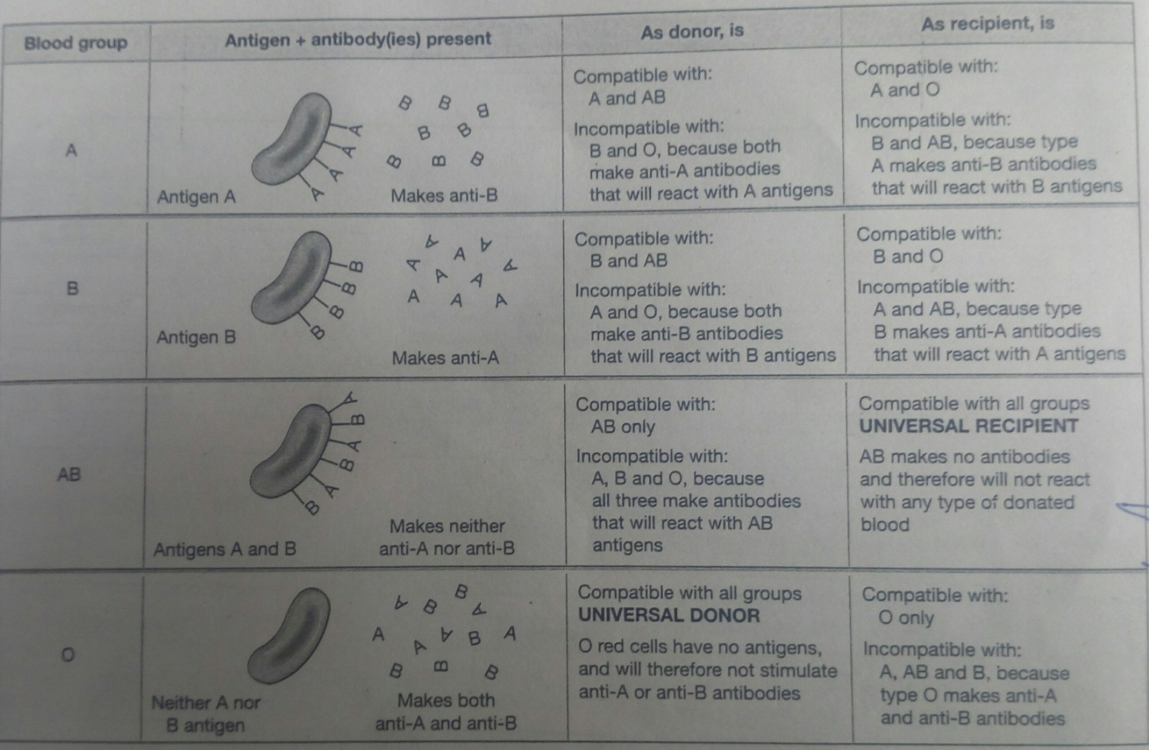
The ABO system
The Rhesus system
The red blood cell membrane antigen important here is the Rhesus(Rh) antigen, or rhesus factor. About 85% of people have this antigen ; they are Rhesus positive(Rh⁺) and do not therefore make anti-rhesus antibodies. The remaining 15% have no Rhesus antigen (they are Rhesus negative or Rh⁻). Rh⁻ individuals are capable of making anti-Rhesus antibodies, but are stimulated to do so only in certain circumstances, e.g. in pregnancy or as the result of an incompatible blood transfusion.
The blood transfusion
Intravenous infusion of the blood is called as blood transfusion. Total blood transfusion allows the transfer of those elements that are required for the defence against infection, the transport of O₂ and the formation of platelet plug( a white thrombus). Blood transfusion reestablishes the blood circulation and corrects the conditions of shock and vascular collapse. It also supplies the clotting factors. The blood can be stored for 2-3 weeks in refrigerator at +4ºc.
Indications
- Haemmorhage either acute or chronic
- Shock (e.g. hypovolomic shock)
- Blood disorders, e.g. anemias, new born hemophilia, purpura, thalassemia etc.
- Excessive blood loss due to accidents or injuries
- Problem with haemopoiesis
Hazards of incompatible blood transfusion: when mismatched blood is transfused to a recipient whose serum contains antibodies against that type of blood group, serious complications even leading to death can occur. The red cells are agglutinated and later on undergo hemolysis. The results of incompatible blood transfusion are summarized below:
Agglutination of red blood cells and hemolysis
Jaundice: Due to breakdown of erythrocytes, bilirubin is released as a product. When the bilirubin concentration in the blood rises it causes jaundice.
Hemoglobinuria: the hemolysis releases Hb and some of it is released with the urine.
Renal failure: decreased renal perfusion may lead to decreased glomerular filtration rate and even renal failure.

